IOT Based Health Monitoring Using MSP-CC3200

M.Nandhini1, A.Jenifer shanthini1, V.Parimala1, S.Janani1, P.Suresh2

Department of Electronics and Communication Engineering

Sri Ramakrishna Institute Of Technology

Coimbatore, Tamil Nadu

nandhiniecesrit@gmail

*Abstract*—Internet Of Things (IOT) is a new technological paradigm that can connect things from various fields through the internet. Based on WHO and other sources, chronicle diseases and psychological pressures are the main reasons behind the 80% of the death of the people. Health monitoring system with multiple sensor nodes are deployed on the different positions of the body are used in the measure of subject’s body temperature,bloodpressure,heart beat rate and ECG.It continuously monitors the vital parameters for a patients and data logging continuously. If any critical situation arises for a patient, this unit rise an alert signal and communicates to the mobile app using IOT through MSP-CC3200 .It will collect and transfer the information to the doctor.IOT ensures the effective and efficient care of patient in any environment. The usage of the advanced technology on patient can be taken care at any type of environment, absolutely eradicates the death rate of the people.

*IndexTerms*—Bloodpressure,ECG,HeartBeat,IOT,MSP-CC3200,Temperature

# I.Introduction

W

e all agree that health life is our fundamental right which is the main objective of World Health Organization as well. According to WHO and other sources, chronicle diseases and psychological pressures are the main reasons behind the death of 80% of the people. Due to technological development, environmental stress and work pressure people suffer because of these stresses which will mainly affect the health of the people. Therefore, it becomes essential for individual to make use of modern health care system to keep themselves healthy and fit.

Vital-sign monitoring is a fundamental component of hospital patient care[1]. A patient’s heart Beat rate ,temperature and blood pressure are some of the essential parameter that are useful in identifying clinical deterioration and it must be measured and recorded accurately. The existing standard of care in most hospitals is continuous monitoring in high-dependency and intensive care areas, and intermittent spot-check monitoring on general wards. Patients in intensive care units (ICUs) are suffering life-threatening conditions and can deteriorate very quickly, thus their vital signs are monitored continually and in real time by attaching the patients to bedside monitors using multiple wires and cables. Although patients in ICU s are immobile and being tethered to the bed by wires and cables. Inadequate cleaning of cables can lead to infection, the large number of cables can make it difficult to access the patient to provide care, and cables can become easily disconnected, leading to loss of signal or false reading. These may leads to the death of the patient. The healthcare industry is in emerging need for change. Hence it is our duty to resolve the health issue of the patients.

This paper presents a healthcare solution that combines web app and MSP-CC3200 in a wireless sensor network to monitor the health condition of patient and provide a wide range of effective, comprehensive, and convenient healthcare services. The specialist or the person who takes care of the patient staying at a distance can effectively monitor the health conditions of the patients continuously so that he can save the life of the patient. IOT is a new technological paradigm that can connect things from various fields through the internet. This health monitoring system uses IOT so that we can monitor the patient condition easily from anywhere. The system continuously monitors the heartbeat, temperature and blood pressure of the patient dynamically and is connected to cloud using IOT, according to the concept of CC3200 .This paper presents a working model which incorporates sensors and transferred the information to the microcontroller CC3200, so that the patient condition can be analyzed by doctors .The health measurement are displayed in the LCD. If the patient reaches any abnormal condition that is beyond the specified threshold valve an alert signal will be passed to the relation of the patient and to the doctor’s mobile phone through app. The usage of these advanced technologies on patient can be taken care at any type of environment and also reduced the death of the people.

# II.RELATED WORK

Energy efficient long-term continuous personal health monitoring system provides a secure energy efficient system for long term continuous health monitoring.The system evaluated various schemes with the help of eight bio-medical sensors and also evaluated the storage requirements for long-term analysis.The system evaluated four schemes among that CS-based scheme provide the most computational energy savings.The system uses sensors like heart rate,bloodpressure,oxygensaturation, bodytemperature, blood glucose,accelerometer,electro-cardio-gram,electroencephalogram(EEG),which continuously monitors the respective health parameter and transmit to the base station and the storage unit.

The rapid advances in bio-medical sensors , low power electronics and wireless communication have brought this vision to the verge of reality.Some of the key challenges still remain to be addressed.Constrained size of IWMD’S imply the designs with very limited processing storage and battery capacities.Therefore there is a very strong need for efficiencyin data collection analysis, storage and communication.

# III.EASE OF USE

In this section, we first describe our components used to get the long-term continuous health monitoring that consists of four sensors. Then, we discuss about the transmission app.

## A. Temperature sensor

It measures the hotness and coolness of an body. its working base is voltage which is read across the diode. When the voltage increases temperature also rises. it records voltage drop between voltage base and emitter. theamplication of difference in voltage will generate analog signal that is proportional to temperature[3]. The body temperature normally fluctuates over the day, continues monitoring of these small fluctuations is suggested by different researches for a variety of applications[7]. Suggest measurements at 10 –min intervals to determine the influence of circadian rhythmicity and sleep on 24-hour leptinvariations.however, some application require a higher sampling rate.

## B.Blood pressure

It is also known as transducer. It converts pressure into an analog electrical signal such as voltage or current output which can be measured easily. The force applied will deflect the diaphragm inside the transducer which is measured and converted into electrical output. it can be monitored[6]by programmable controllers, microcontrollers and computer. Mostly transducers are designed to produce linear output. During a typical ambulatory blood pressure monitoring[3] session, he blood pressure is commonly measured every 15 to 30 minutes over 2-hour period. In some cases (eg,occurrence of a hemorrhage),the blood pressure should be sampled at a much higher frequency[5].

## C. Heart rate sensor

The heart rate is commonly sampled at 6-8HZ frequency. For example, this sampling rate is currently used in fetal heart rate monitoring[4]. While the typical human heart rate is 65-82 beats per minute (bpm),the rate can sometimes exceed 180 bpm .these considerations suggest a sampling rate of 2-8 HZ. An accurate and compact low-power heart rate sensor for home-based health care monitoring is described and implemented in[10].it shows that a resolution of 10 bits is appropriate for providing an accurate measurement of the heart rate.

## D. ECG sensor

Recently, wearable health monitoring devices plays a vital role in tele-healthcare, such devices ranging from pulse monitors[2], portable ECG monitors, fall detection, activity monitors, through to implantable sensors, typically , the ECG equipped with electrodes(ECG sensors) attached to lower/upper chest to quantify the cardiac activity based on short samples of the electrical activity of the heartbeat between the different electrode pairs[8]. Several bio-monitor systems are used to provide continuous monitoring of several physiological parameters. These systems are engaged to detect, to process and to record the signals.

Ultra low-power ECG sensors, which re commonly used in long-term monitoring[9], support 8 or 12 bits of resolution. A resolution of 8 bits of resolution will meet ECG requirement.therefore,we assume a resolution of 12 bits.

## E. blynk app

It is the most user-friendly IOT platform for a reason. It is a smartphone application that allows us to create an interface that interacts with Internet –connected hardware, the interface can be freely downloaded into smart phones, and can be used for the remote monitoring and control of IOT –controlled devices. To prevent misuse and unauthorized access, the application requires the user to enter an authentication code, which is sent to hem via an email.users may share this code with other individual they wish to grant access to.all data stored on the BLYNK server, and can be exported by the user, in the form of csv file. this data can then be used for further analysis.

This is necessary for the purpose of security, this ensures that only authorized users can control the electrical appliances and other cannot misuse it.by using this facility information of the patient can be secured.

# IV.SYSTEM DESIGN

In this section, we first describe two fundamental parts that form the continuous health monitoring, namely biomedical sensors and controller section. Second, we discuss the communication protocols, which can used to connect them together.

## Health monitoring using biomedical sensor

Biomedical sensors have been used for health monitoring for a longtime monitoring..They have the dense electrical, thermal, optical, chemical, and other signals to extract information that are indicative of a patient’s health condition. Examples of such sensors include blood pressure, temperature, heart beat rate, ECG and several forms of imaging.

In addition to the biomedical sensors, an important component of a health monitoring system is the controller unit. Controller used in the monitoring is MSP-CC3200.With the help of this controller, the measured information through the sensor is controlled and displayed in the LCD.This controller has the feature of in-built WI-FI so the information can be transmitted wireless also.

## Communication protocol

A Key consideration in the design of this system is the communication technology used to connect the medical sensors with the base station. Here we used the controller to transmit the information to the app using IOT. This paper uses the app called Blynk, which is the most user- friendly IOT platform. It is a Smartphone application that allows us to create an interface that interacts with Internet-connected hardware.smartphones have become dominant over other forms of base station for potential use in the health monitoring system. Due to the privacy and safety concerns in medical systems, security is a key consideration in this system design.

# V.methodology and procedures

The proposed system consists of three stages. They are sensor implementation, coding installation and transmition of information to blynk app.

The real time implementation of the system is discussed in this section.In the schematic block diagram,the working principle of the IoT based wearable health monitoring system using CC3200 is explained.Block consists of temperature sensor, pulse sensor, pressure sensor and CC3200.The sensing part will sense the temperature,heart rate ECG and blood pressure of the pregnant women and it sends the analog signal to the microcontroller CC3200.The controller consists of in-built ADC and wifimodule.Hence the analog input signal is converted into digital signal which is then transferred to cloud.In transmitting part,the information is send to the pc of doctor via an IP address.If the values are abnormal i.e,varying over a small range than the presetvalue,this information will be received by the doctor along with an alarm sound.Hence the doctor will send back prescription to the patient’s IP address.If the values exceed than a critical range then the doctor will call the ambulance and this information will be send to the relative of the patient along with an alarm.

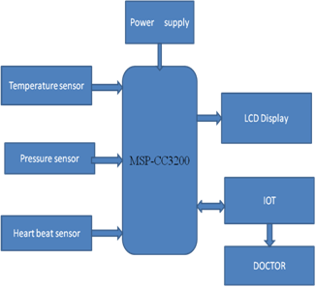

Fig.1.Block diagram of IOT based health monitoring system using MSP-CC3200

# VI.code for msp-cc3200

The following code is used sense the temperature, blood pressure, heartbeat and ECG connected to the MSP-CC3200 and send to the app

include<LiquidCrystal.h>

LiquidCrystallcd(12,11,5,4,3,2);

Constint buzzer = 8;

/*SETTING PORTS & PINS*/

Void setup(){

Serial.begin(9600);

pinMode(buzzer,OUTPUT);

lcd.begin(16,2);

lcd.setCursor(0,0);

lcd.print(“Health Monitoring”);

lcd.setCursor(0,1);

lcd.print(“system”);

delay(2000);

delay(1000);

lcd.clear();

}

/*LOOPING(CONTINUES READING)*/

Void loop(){

digitalWrite(buzzer,LOW);

/*HEART BEAT SENSOR*/

int HEART =analogRead(A0);

int TEMP = 0;

int HEART1 = HEART*0.83333333;

lcd.setCursor(0,0);

lcd.print(“HEART”);

lcd.setCursor(0,1);

lcd.print(HEART1);

/*PRESSURE SENSOR*/

int PRESSURE = analogRead(A1);

int PRESSURE1 = PRESSURE*0.28;

lcd.setCursor(7,0);

lcd.print(“PRES”);

lcd.setCursor(7,1);

lcd.print(PRESSURE1);

/*TEMPERATURE SENSOR*/

TEMP = analogRead(A2);

float TEMP1 = TEMP*0.4124;

lcd.setCursor(12,0);

lcd.print(“TEMP”);

lcd.setCursor(12,1);

lcd.print(TEMP1);

/*DELETE CHARACTERS*/

delay(1000);

lcd.setCursor(12,1);

lcd.print(“ “);

lcd.setCursor(7,1);

lcd.print(“ “);

lcd.setCursor(0,1);

lcd.print(“ “);

/*EMERGENCY CONDITION*/

if(HEART1>=200)

{

for(int y=0;y<=50;y++)

{

lcd.clear();

lcd.setCursor(0,0);

lcd.print(“HEART”);

lcd.setCursor(7,0);

lcd.print(HEART1);

lcd.setCursor(0,1);

lcd.write(“EMERGENCY”);

digitalWrite(buzzer,HIGH);

delay(50);

digitalWrite(buzzer,LOW);

delay(50);

lcd.setCursor(0,1);

lcd.write(“ “);

}

delay(100);

digitalWrite(buzzer,LOW);

lcd.setCursor(0,0);

lcd.write(“ “);

/*SMOKE EMERGENCY*/

if(PRESSURE1>=50)

{

for(int y=0;y<=50;y++)

{

lcd.clear();

lcd.setCursor(0,0);

lcd.print(“PRES”);

lcd.setCursor(5,0);

lcd.print(PRESSURE1);

lcd.setCursor(0,1);

lcd.write(“EMERGENCY”);

digitalWrite(buzzer,HIGH);

delay(50);

digitalWrite(buzzer,LOW);

delay(50);

lcd.setCursor(0,1);

lcd.write(“ “);

}

delay(100);

digitalWrite(buzzer,LOW);

lcd.setCursor(0,0);

lcd.write(“ “);

/*TEMPERATURE EMERGENCY*/

if(TEMP1>=40)

{

for(int y=0; y<=50; y++)

{

lcd.clear();

lcd.setCursor(0,0);

lcd.print(“TEMP”);

lcd.setCursor(6,0);

lcd.print(TEMP1);

lcd.setCursor(0,1);

lcd.write(“EMERGENCY”);

digitalWrite(buzzer,HIGH);

delay(50);

digitalWrite(buzzer,LOW);

delay(50);

lcd.setCursor(0,1);

lcd.write(“ “);

}

delay(100);

digitalWrite(buzzer,LOW);

lcd.setCursor(0,0);

lcd.write(“ “);

}

# VII.FLOWCHART

The following flowchart represent the flow of health monitoring system using MSP-CC3200 by the help of the IOT concept. The monitoring system first measures the various parameters like heartbeat,temperature,ECG and Blood pressure using the different sensors deployed on the different position of the body.If the health parameter are maintained under the normal condition means it displays the output to the LCD and continues the same flow of operation.If the parameter beyond the value means it sends the alert signal to the blynk app which can sends to doctor or to the person who will take care of the patient.By using this system continuous monitoring is possible and emergency or critical conditions can be avoided.the spontaneous monitoring helps in the saving the life of the patient under any kind of situation.the system helps in the long distance transmission of information without any lost of data.the patient detatails is secured and didn’t create a chanced in the leek of the patient health deatails.The complete flow diagram is shown below.

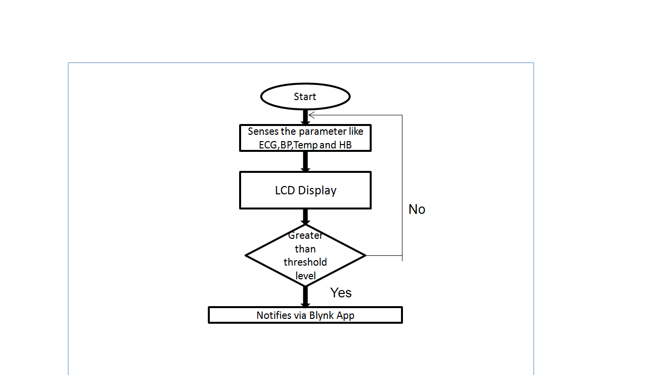

Fig.2.Flow Chart of monitoring system

# VIII.conclusion

Currently available system is not compact and wearable .Hence it occupies more space and measurement capacity is not that good. But the system we proposed will collect and transfer the information to the doctor at the earliest because of IOT and the product is compact and wearable. So it is easy for the doctor to analyze the health condition of patient continuously .Since we use IOT ,it is easy to retrieve the previous record which is used for analyzing during complications.CC3200 of TI company is used for complete process which is cost efficient, the results are accurate and precise.It helps patients to avoid unexpected death and the doctors are able to suggest healthy diet to the patient from their place itself through IoT.Finally,the compared all proposed schemes and discussed a continuous long-term health monitoring system should be configured based on patient’s needs and physician’s recommendations.

# References

[1]R.C.King,E.villeneuve,R.J.White,R.S.Sherratt,W.Holderbaum and W.S.Harwin,”Application Of Data Fusion Techniques and Technologies For Wearable Health Monitoring”medical engineering &physics,vol.42,pp.1-12,apr.2017.

[2]Z.A.Khan and W.Sohn,”Abnormal Human Activity Recognition System Based on R-Transform and Kernel Discriminant Technique for Elderly Home Care”IEEE Trans.Consum.Electron..,vol.57,no.4,pp.1834-1850,feb.2011.

[3]J.Yick,B.Mukherjee,and D.Ghosal,”Wireless Sensor Network Survey”Computer Network,vol.52,no.12,pp.2292-2330,2008.

[4]L.D.Durosier,G.Green,I.Batkin,A.J.Seely,M.G.Ross,B.S.Richardson,and M.G.Frasch,”Sampling Rate Of Heart Rate Variability Impacts The Ability To Detect Acidemia in Ovine Fetuses Near-Trem”,Frontiers in Pediatrics,vol.2,p.38,2014.

[5]V.N.Hedge,R.Deekshit and P.S.Satyanarayana,”Heart Rate Variability Analysis for Abnormality Detection Using Time Frequency Distribution Smothed Pseudo winger Ville Method,”Power(dB),vol.30,no.20,p.10,2013.

[6]G.Mancia,A.Zanchetti,E.Agebiti-Rosei,G.Benemio,R.DeCesairs,R.Fogari,A.Pessino,C.Porecellati,A.Selvetti,B.Trimarco et al.,”Ambulatory Blood Pressure Is Superior To Clinic Blood Pressure in PredicitingTreament-Induced regression of LeftVentricularHypertrophy,” Circulation,vol.95,no.6,pp.1464-1470,1997.

[7]C.Simon,C.Gronfier,J.Schlienger,G.Brandenberger,”Circadian and Ultradian Variation of Leptin in Normal Man Under Contionous Enteral Nutrition:Relationship to Sleep And Body Teamperature,”J.ClinicalEndocrinologyAndMetabolism,vol.83,no.6.pp.1893-1899,1998.

[8]A.S.Berson,F.Y.Lau,J.M.Wojick,andH.V.Pipberger,”Distortions in infant Eletrocardiograms Caused by Inadequate High FrequencyResponse,”AmercianHeartJournal,Vol.93,no.6,pp.730-734,1977.

[9]F.Simon, J.PMartinez,p.Laguna,B.VanGrinsven,C.Rutten, and R.Houben,”Impact Of Sampling Rate Reduction On Automatic ECG Delineation,” in Proc.IEEE 29th Annual Int. Conf.EngineeringinMedicineandBiologySociety,2007,pp.2587-2590.

[10]M.Chen,O.Boric-Lubecke,V.Lubecke,and X.Wang,”Analog Signal Processing For Heart Rate Extraction”,inProc.IEEE 27th Annual Int.Conf.Engineering in Medicine and Biology Society,2005,pp.6671-6674.

.